ABD SQL QUIZ

**Q1. Write sql query to create a new empty (no records) table which is same as existing table with ‘n’record.**

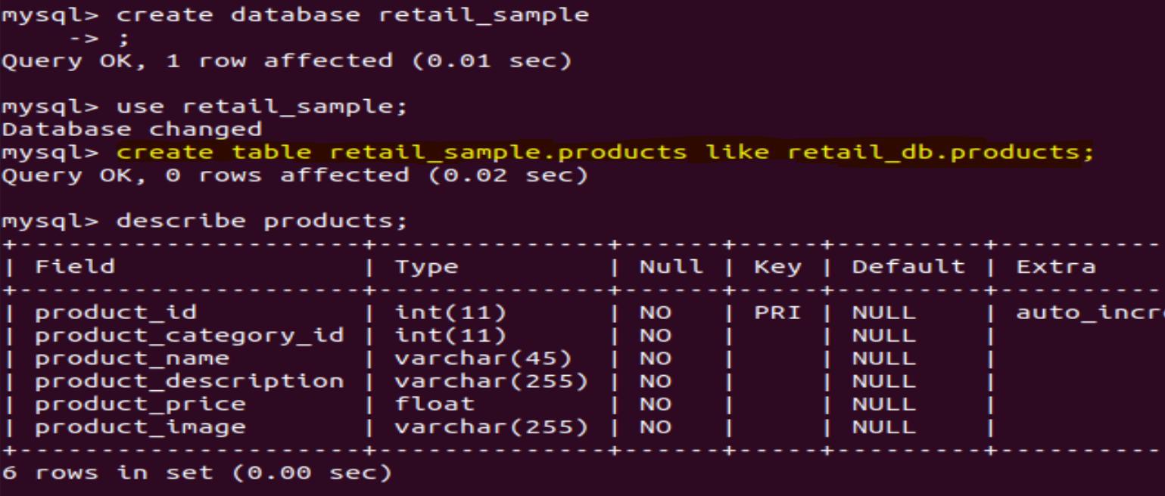

**Q2. Assume that employee table has fields like emp_id, fname, lname, department_id, status and salary. Department table has fields like department_id, department_name, employee_count. Can you provide a list of active (based on the value of ‘status’ field) employees, including their first names, last names, and the names of the departments they belong to?**

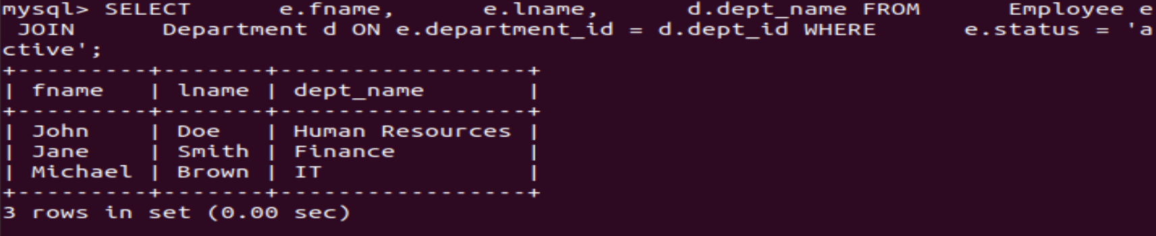

**Q3. From tables in Q2 "Can you provide a list of employees along with their employment status, categorizing them as 'Active with Projects' if they are currently active and assigned to projects, or 'Inactive or No Projects' otherwise?"**

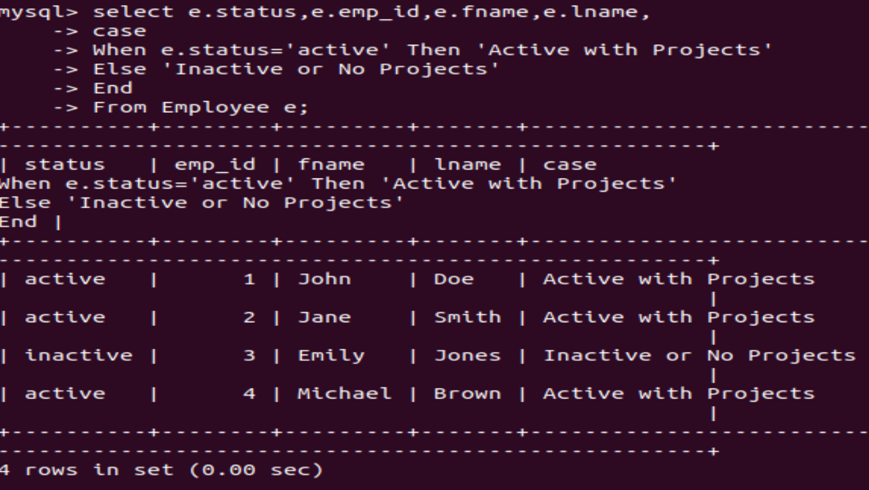

**Q4. Emplyoee table has fields like emp_id, emp_name, department, manager_id and designation. Write SQL query to find departments in the employees table have more than 10 employees. Please list each department along with the count of employees in those departments.**

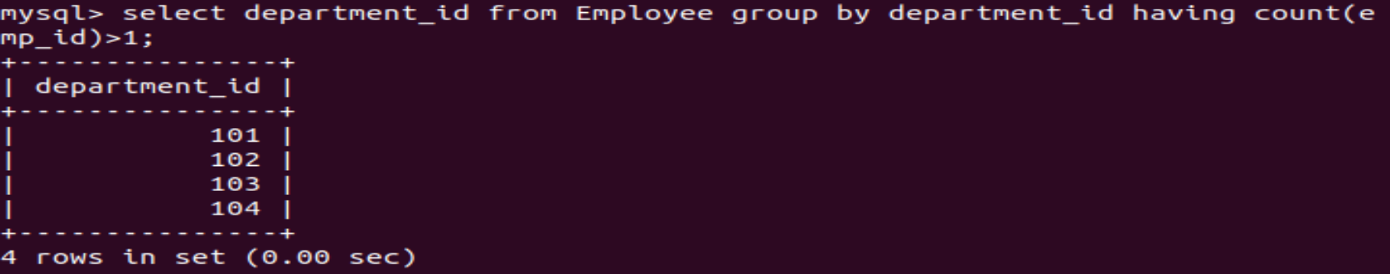

**Q5. For employees table in Q2 find highest paid employees from each department.**

